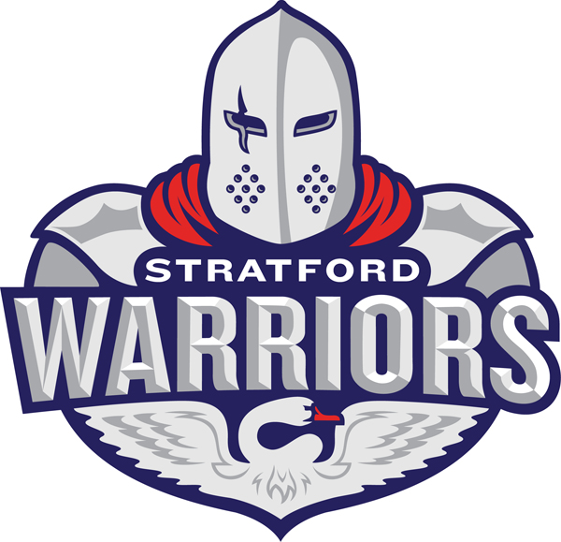
STRATFORD MINOR HOCKEY ASSOCIATION
COACHING APPLICATION FOR THE 2017-2018 SEASON
APPLICATION DEADLINE: FRIDAY, FEBRUARY 24, 2017
SECTION 1: CONTACT INFORMATION
Name of Applicant:
Home Phone: Cell Phone:
Work Phone: Birth Date:
(Emergencies Only) (yyyy/mm/dd)
Email Address:
Home Address:
City: Postal Code:
Employer: Job Position/Title:
SECTION 2: TEAM APPLICATION
I wish to apply as Head Coach for the following team:
SEEDED Minor Atom A/AA MINOR DEVELOPMENT Novice Tier I
Major Atom A/AA Novice Tier II
Minor Peewee A/AA Novice Tier III
Major Peewee A/AA Minor Atom MD
Minor Bantam A/AA Major Atom MD
Major Bantam A/AA Minor Peewee MD
Minor Midget A/AA Major Peewee MD
Major Midget A/AA Minor Bantam MD
Major Bantam MD
Minor Midget MD
Major Midget MD

Would you be willing to coach a team that you did not apply for? Yes No
List below any people you are considering for part of your coaching staff:
Name | Position

SECTION 3: EXPERIENCE/QUALIFICATIONS
Please provide details of prior coaching positions held:
Year: Association: Position:
Year: Association: Position:
Year: Association: Position:

Do you have your NCCP Coaching Certification:
If yes, what is your NCCP Coach Level?
Development 1 Coach 1 - Intro Coach Coach 2 - Coach Level
NOTE: ALL COACHES AND STAFF MUST COMPLETE ANY OUTSTANDING CERTIFICATIONS BY
SEPTEMBER 30, 2017. PLEASE DO NOT DELAY IN SIGNING UP FOR A COURSE AS THEY FILL UP EARLY!

SECTION 4: REFERENCES
Coaching:
Name: Phone:
Non-Coaching:
Name: Phone:
I agree to ensure staff (including managers) obtain a Police Vulnerable Sector Check (Police Check) and be approved by the Coaches Selection Committee. If staff have submitted a Police Check to SMHA dated 2015, 2016 or 2017, they will not be required to submit a new one, however, they must notify the Risk Management Committee should they have committed an offence since their previous check. By accepting a position with SMHA, they declare that there have been no changes to their previous check.
I acknowledge and agree to the above named references being contacted. I am aware that other persons and organizations may also be contacted. I give permission to these persons/organizations to provide information about myself to the Stratford Minor Hockey Association (SMHA) for purposes of this application.
If accepted to a coaching position with SMHA, I agree to uphold and abide by any rules and regulations as set forth by the Association, the SMHA Constitution and the goals and philosophies of the Association.
I further understand and agree that as Head Coach I bear ultimate responsibility for any and all team staff conduct or lack of performance in their duties. It is also understood that all signing parties are subject to discipline or suspension at the SMHA Board of Directors discretion.
I AGREE to all terms and conditions.

Name: Signature: Acknowledgement of Signature

Please return completed application by Friday, February 24, 2017
to the Coaches Selection Committee at applications@stratfordminorhockey.com
(or mail/drop off to 21 Kay Street, Stratford, Ontario N5A 7R7)

Please contact Mike Graham (519-301-7207) should you have any questions.

Thank you for taking time to apply with Stratford Minor Hockey!

